Identify whether the facial expression is positive, negative, or neutral. (Circle one)
What feeling words can you associate with each of the following facial expressions? Write a feeling word on the line provided.

Positive
Negative
Neutral

Feeling Word: _____________________

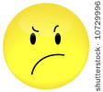
Positive
Negative
Neutral

Feeling Word: _____________________

Positive
Negative
Neutral

Feeling Word: _____________________

