Detective Log

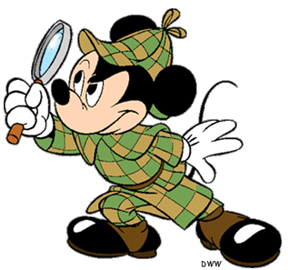

**Chapters**

**Chapters**